Andrew Dykman – Lab 6 – Software Development Lifecycles

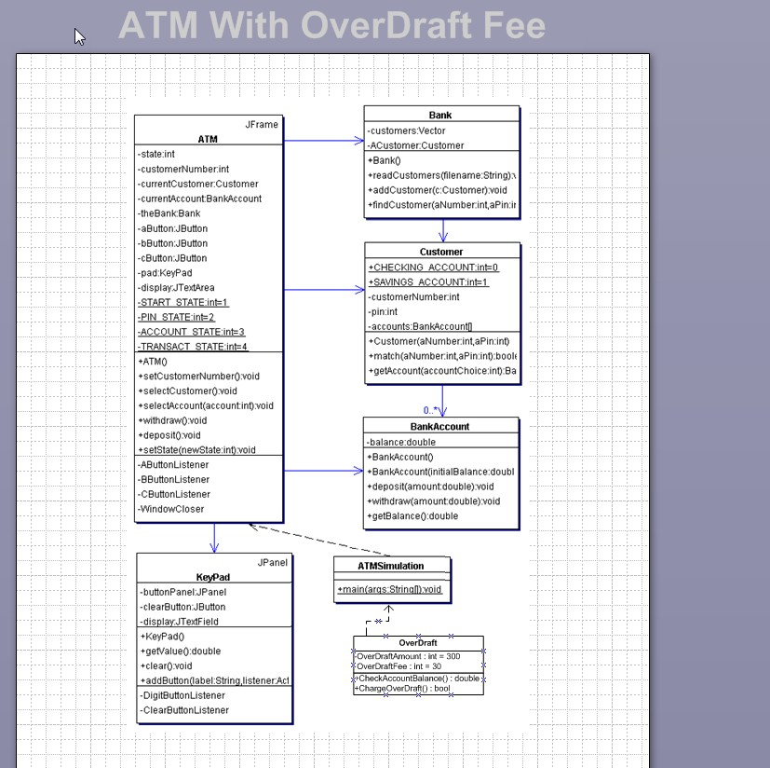
Question A.) setCustomerNumber(), selectCustomer(), selectAccount(account int), withdraw(), deposit(), setState(newState: int), Keypad(), getValue(), clear(), addButton(label: String, listener:ActionListener), readCustomers(filename String), addCustomer(c: Customer), findCustomer(aNumber:int, aPin:int), BankCcount(intialBalance:double), deposit(amount double),withdraw(amount:double), getBalance(), main(args:String[]), CheckAccountBalance(acctBalance:double), ChargeOverDraftFee(acctBalance:double)

B.) The Same

Part 2:

PseudoCode for Withdraw Method (Both Checking and Savings):

import atm.ATM;
import atm.Session;
import atm.physical.*;
import banking.AccountInformation;
import banking.Card;
import banking.Message;
import banking.Money;
import banking.Status;
import banking.Receipt;
/** Representation for a cash withdrawal transaction
*/
public class Withdrawal extends Transaction
{
/** Constructor
*
* @param atm the ATM used to communicate with customer
* @param session the session in which the transaction is being performed
* @param card the customer's card
* @param pin the PIN entered by the customer
*/
public Withdrawal(ATM atm, Session session, Card card, int pin)
{
super(atm, session, card, pin);
}
/** Get specifics for the transaction from the customer
*
* @return message to bank for initiating this transaction
* @exception CustomerConsole.Cancelled if customer cancelled this transaction
*/
protected Message getSpecificsFromCustomer() throws CustomerConsole.Cancelled
{
from = atm.getCustomerConsole().readMenuChoice(
"Account to withdraw from",
AccountInformation.ACCOUNT_NAMES);
String [] amountOptions = { "$20", "$40", "$60", "$100", "$200" };
Money [] amountValues = {
new Money(20), new Money(40), new Money(60),
new Money(100), new Money(200)
};
String amountMessage = "";
boolean validAmount = false;
while (! validAmount)
{
amount = amountValues [
atm.getCustomerConsole().readMenuChoice(
amountMessage + "Amount of cash to withdraw", amountOptions) ];
validAmount = atm.getCashDispenser().checkCashOnHand(amount);
if (! validAmount)
amountMessage = "Insufficient cash available\n";
}
return new Message(Message.WITHDRAWAL,
card, pin, serialNumber, from, -1, amount);
}
/** Complete an approved transaction
*
* @return receipt to be printed for this transaction
*/
protected Receipt completeTransaction()
{
atm.getCashDispenser().dispenseCash(amount);
return new Receipt(this.atm, this.card, this, this.balances) {
{
detailsPortion = new String[2];
detailsPortion[0] = "WITHDRAWAL FROM: " +
AccountInformation.ACCOUNT_ABBREVIATIONS[from];
detailsPortion[1] = "AMOUNT: " + amount.toString();
}
};
}
/** Account to withdraw from
*/
private int from;
/** Amount of money to withdraw
*/
private Money amount;
}

PseudoCode for Transfer Method:

package atm.transaction;
import atm.ATM;
import atm.Session;
import atm.physical.*;
import banking.AccountInformation;
import banking.Card;
import banking.Message;
import banking.Money;
import banking.Status;
import banking.Receipt;
/** Representation for a transfer transaction
*/
public class Transfer extends Transaction
{
/** Constructor
*
* @param atm the ATM used to communicate with customer
* @param session the session in which the transaction is being performed
* @param card the customer's card
* @param pin the PIN entered by the customer
*/
public Transfer(ATM atm, Session session, Card card, int pin)
{
super(atm, session, card, pin);
}
/** Get specifics for the transaction from the customer
*
* @return message to bank for initiating this transaction
* @exception CustomerConsole.Cancelled if customer cancelled this transaction
*/
protected Message getSpecificsFromCustomer() throws CustomerConsole.Cancelled
{
from = atm.getCustomerConsole().readMenuChoice(
"Account to transfer from",
AccountInformation.ACCOUNT_NAMES);
to = atm.getCustomerConsole().readMenuChoice(
"Account to transfer to",
AccountInformation.ACCOUNT_NAMES);
amount = atm.getCustomerConsole().readAmount("Amount to transfer");
return new Message(Message.TRANSFER,
card, pin, serialNumber, from, to, amount);
}
/** Complete an approved transaction
*
* @return receipt to be printed for this transaction
*/
protected Receipt completeTransaction()
{
return new Receipt(this.atm, this.card, this, this.balances) {
{
detailsPortion = new String[2];
detailsPortion[0] = "TRANSFER FROM: " +
AccountInformation.ACCOUNT_ABBREVIATIONS[from] +
" TO: " +
AccountInformation.ACCOUNT_ABBREVIATIONS[to] ;
detailsPortion[1] = "AMOUNT: " + amount.toString();
}
};
}
/** Accounts to transfer from
*/
private int from;
/** Account to transfer to
*/
private int to;
/** Amount of money to transfer
*/
private Money amount;
}
C.) No, because transfer is between checking and savings or vice-versa.

Checking Account Decision Table
 |  | Rules
Conditions | Transfer(chkAccountBalance, transferAmount) (transferAmount <= accountBalance) | Y
Conditions | Transfer(chkAccountBalance, transferAmount) (transferAmount >= accountBalance) | N
Conditions | Overdraft(chkAccountBalance, overdraftAmount) (overdraftAmount >= -300 && chkAccountBalanceAmount >= -300) | Y
Conditions | Overdraft(chkAccountBalance, overdraftAmount) (overdraftAmount <= -300 || chkAccountBalanceAmount <= -300) | No
Conditions | Withdraw(accountBalance, withdrawAmount) (accountBalance > 20) | Y
Conditions | Withdraw(accountBalance, withdrawAmount) (accountBalance <= 0) | Y
Conditions | Deposit(depositAmount) (depositAmount > 0) | Y

